

20.02.2024 Our Ref: UFCEA/PI/20022024

Primate Research,

Att. Elias Mukundi,

Thank you for inviting Unga Farm Care to quote for animal feeds.
Kindly find below our price offer:
PROFORMA INVOICE
Product code | Product Name | Quantity bags | Unit Price(Kshs) | Total(Kshs)
FGMICEP050 | Fugo Mice Pencils 50kg | 6 | 3,715 | 22,290
Total |  |  |  | 22,290
PFI valid for 10 days

N/B Prices for our products are subject to change without notice. We reserve the right at any time to rename, modify or discontinue products

Payments payable to:
Unga Farm Care (E.A.) Limited
A/C No: 0708347892
Barclays Bank Enterprise Road Branch customer Code 2000856.

Yours faithfully,

Unga Farm Care Ltd
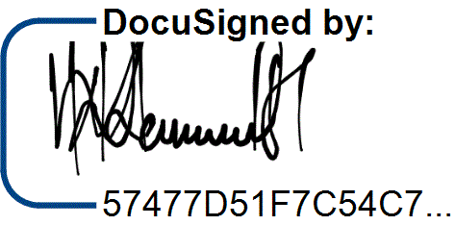

Wilfred Kamau
Business Development Manager

